VA Talent Management System (TMS)
Step-by-step process of self-enrollment in the VA TMS for health professions trainees. Trainees will be able to access the Mandatory Training for Trainees once enrolled in VA TMS.

- Go to VA TMS Webpage: https://www.tms.va.gov/SecureAuth35/

- Click the [Create New User] link in the top menu
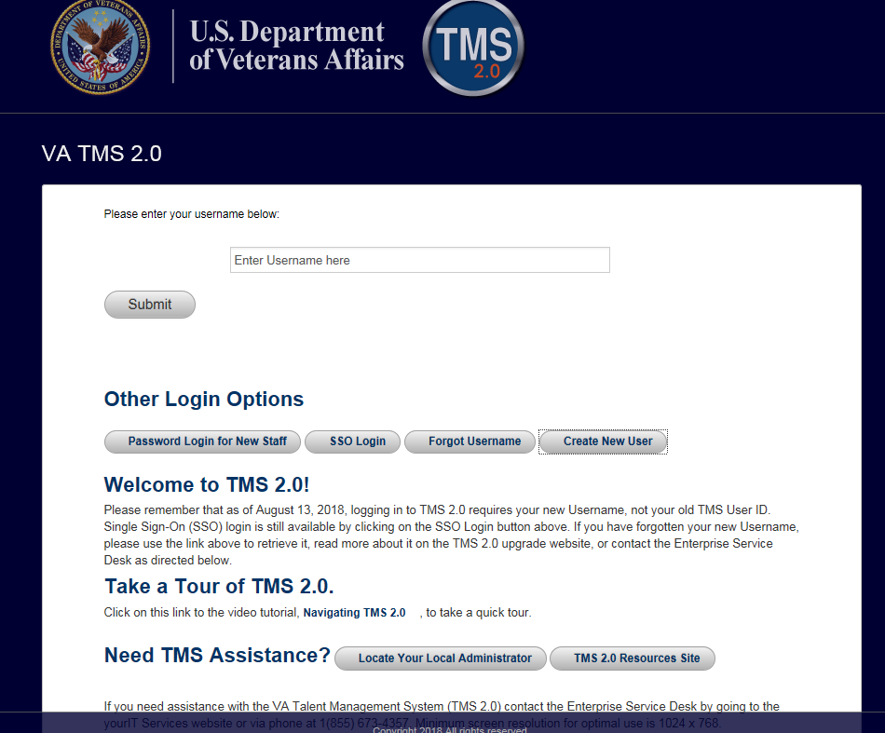
Click [Create New User]

3) Select the radio button for Veterans Health Administration and then Click the Next button
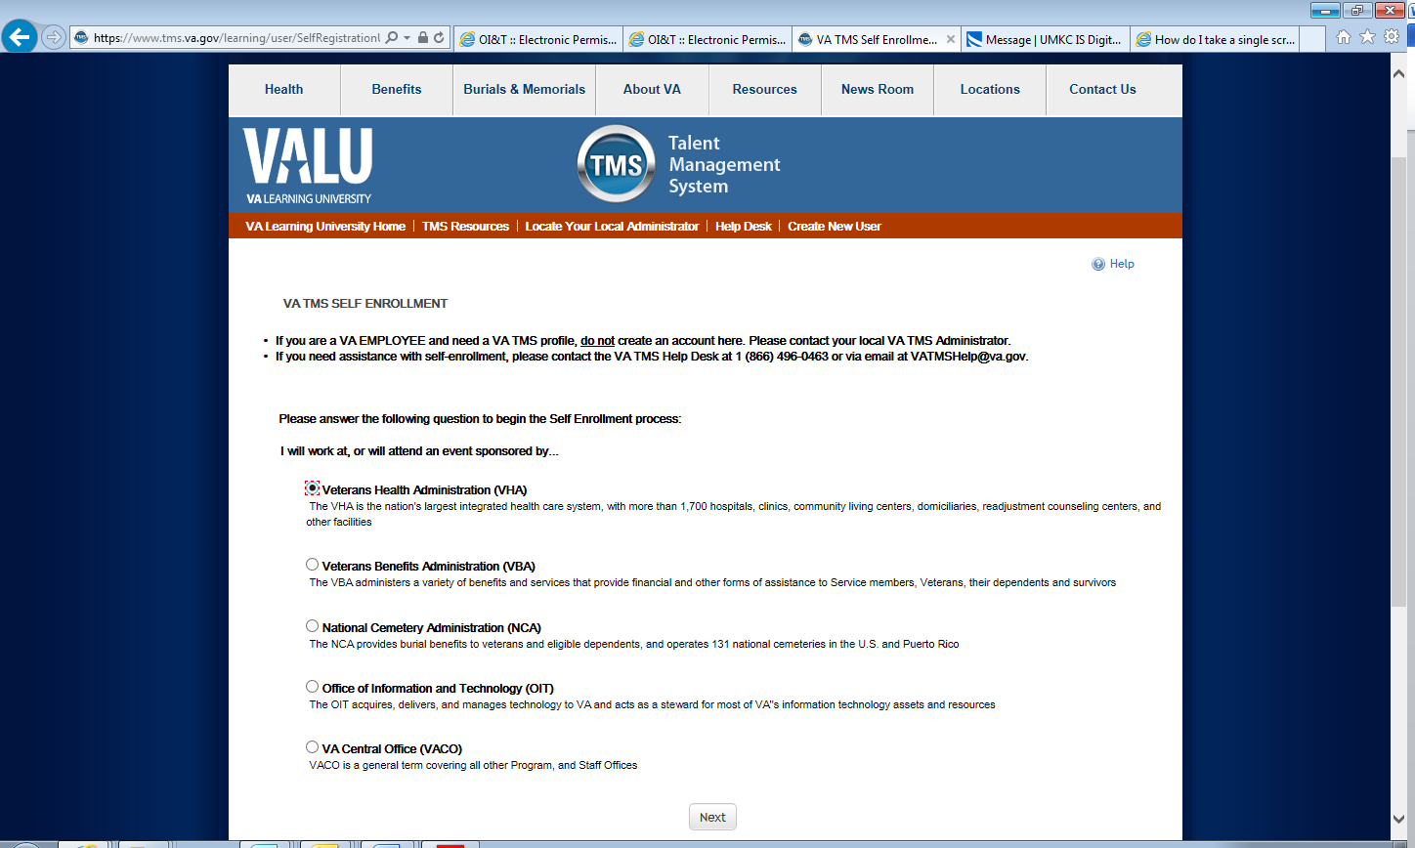

4) Select the radio button for [Health Professions Trainee] and then Click the [Next] button

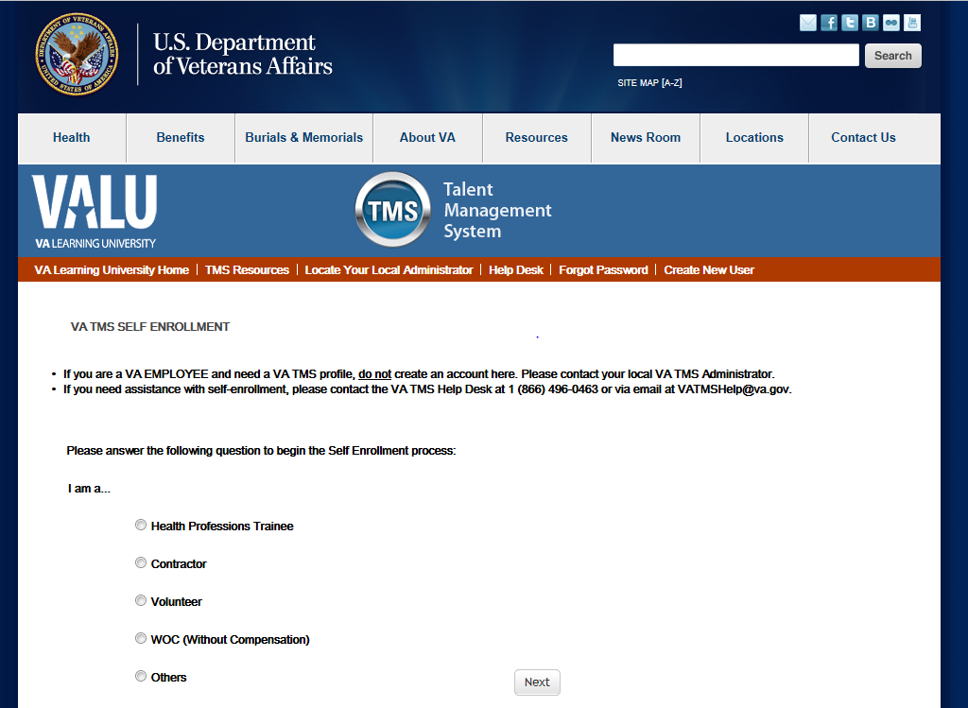
Select [Health Professions Trainee]
Click [Next]

5) In My Account Information section, fill in all required fields as noted by the red asterisk, taking care to type accurately when entering your Social Security Number, e-mail address, and legal name (Your Email will be your TMS User ID) and Mobile Phone Number.

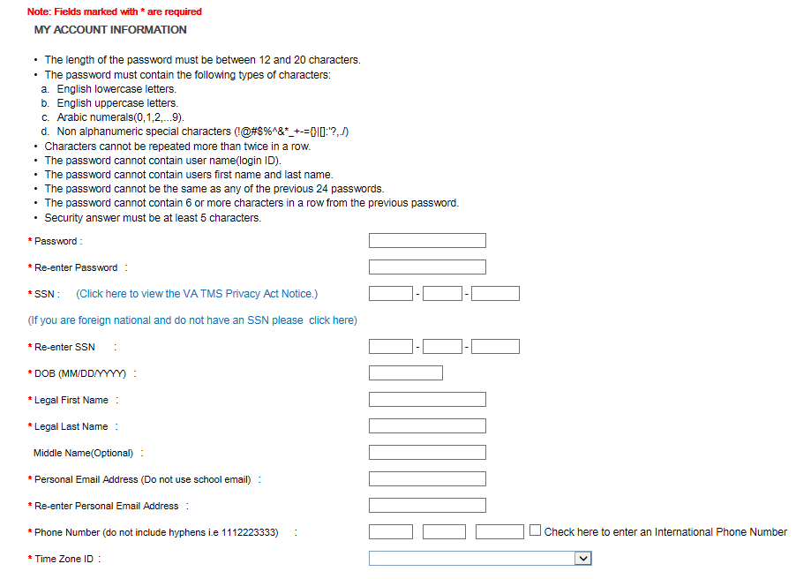
4a) If you do not have a SSN click the [click here] link. This will open an email exchange with VA TMS Help to assist you in creating a user profile. I

6) In My Job Information section, fill in all required fields as noted by the red asterisk, entering the data provided by your VA point of contact where appropriate. (Please make sure VA Location Code, Trainee Type, Specialty are entered and correct)
VA Location: Click on Blue Funnel and search for Kansas City

*Trainee Type: Select Appropriate One

*Specialty/Discipline: Choose your specialty/discipline
i.e. Physician Assistant, etc

*VA Point of Contact First Name: Scott

*VA Point of Contact Last Name: Sheridan

*VA Point of Contact Email Address: scott.sheridan@va.gov

*VA Point of Contact Phone Number: 816 922 2017

*Enter School/University Info

*Enter School University start date and estimated completion date

*Click submit

FAMILY MEDICINE RESIDENTS see 6a
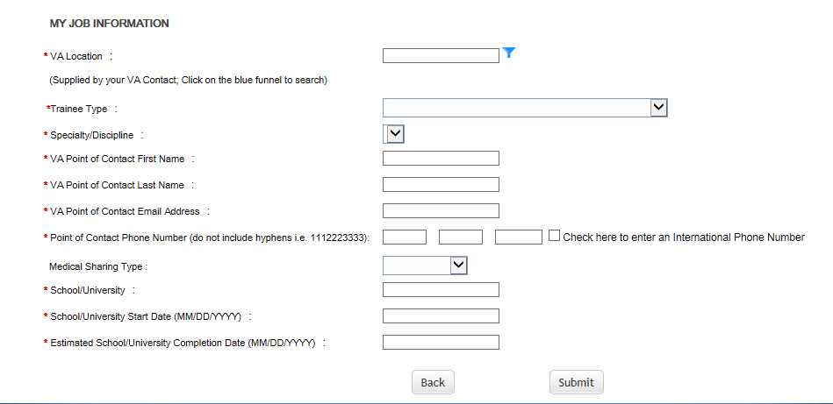

6a.)
VA Location: Click on Blue Funnel and search for Eastern Kansas

*Trainee Type: Select Appropriate One

*Specialty/Discipline: Choose your specialty/discipline
i.e. Physician Assistant, etc

*VA Point of Contact First Name: Kristi

*VA Point of Contact Last Name: Visocsky

*VA Point of Contact Email Address: kristi.visocsky@va.gov

*VA Point of Contact Phone Number: 913-682-2000 ext 52142

*Enter School/University Info

*Enter School University start date and estimated completion date

*Click submit

7) It will take approx. 20mins for your TMS account to be created.
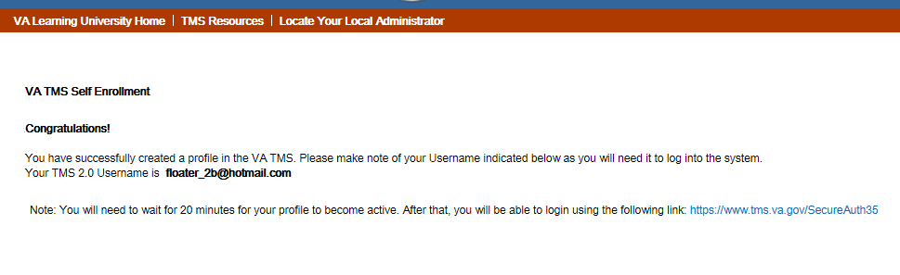

8) After the 20min wait period has expired return to https://www.tms.va.gov/SecureAuth35/
Enter your email address used in your initial set-up and click submit. You will be given an option of having a passcode sent to you by email or Voice text. Enter passcode (see picture 2 below)

(Pic 2)
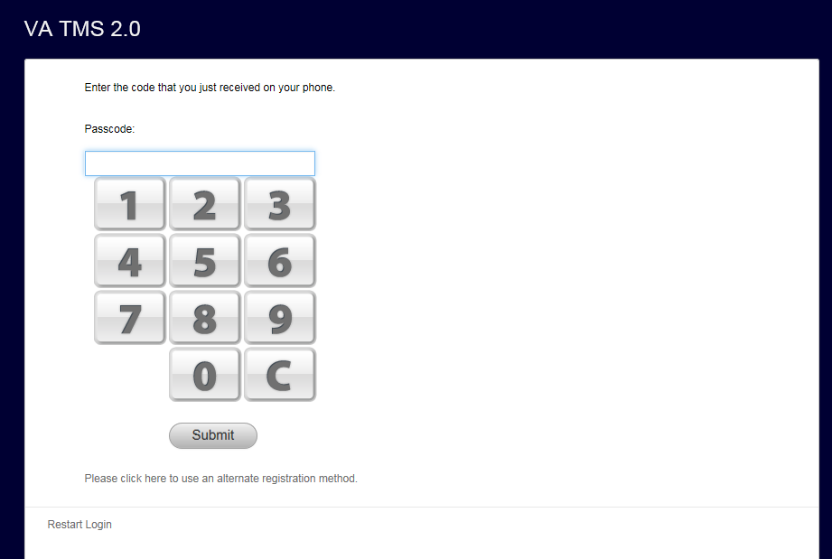

9) Click on your To Do list and complete the Mandatory Training for Trainees Course. Once you have completed the course, at your TMS Home page click on My History and then View All.
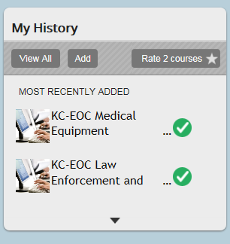
Click on [Completed Work]

10) From the Completed Work page, hover over VHA Mandatory Training for Trainees to display the pop-up menu. Click on [Print Certificate]. Print or Save a copy of your certificate for your records and a copy for your VA program coordinator.
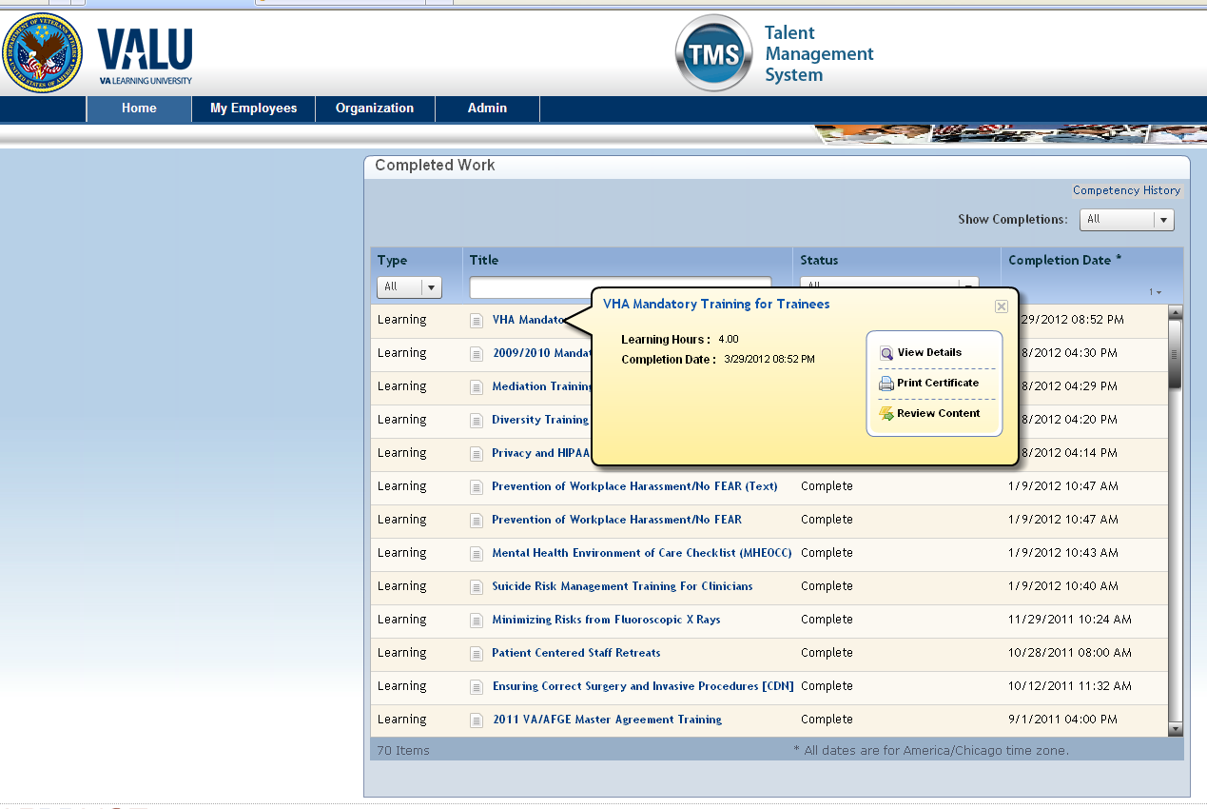
If you have any problems, contact the help desk at 1-855-673-4357, Option 1 and someone should be able to assist you or contact Scott Sheridan at 816-922-2017 or scott.sheridan@va.gov or Kristi Visocsky at 913-682-2000 ext 52142 or kristi.visocsky@va.gov (Family Medicine Only).

